NAME: TASNEEM SADIKOT
PRN: 23070521162
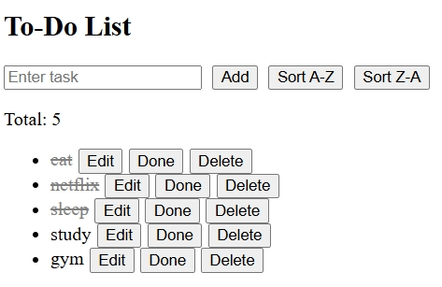
<!DOCTYPE html>
<html>
<head>
<title>Simple To-Do</title>
<style>
li.completed span { text-decoration: line-through; color: gray; }
li:hover { background: #eee; }
button { margin-left: 5px; }
</style>
</head>
<body>
<h2>To-Do List</h2>
<input id="taskInput" placeholder="Enter task">
<button onclick="addTask()">Add</button>
<button onclick="sortTasks(true)">Sort A-Z</button>
<button onclick="sortTasks(false)">Sort Z-A</button>
<p id="count">Total: 0</p>
<ul id="list"></ul>
<script>
const input = document.getElementById("taskInput");
const list = document.getElementById("list");
const count = document.getElementById("count");

window.onload = () => {
(JSON.parse(localStorage.getItem("tasks")) || [])
.forEach(t => createTask(t.text, t.done));
updateCount();
};
input.addEventListener("keypress", e => { if(e.key==="Enter") addTask(); });

function addTask() {
const text = input.value.trim();
if(!text) return;

const exists = [...list.querySelectorAll("span")].some(s => s.textContent === text);
if(exists) { alert("Task already exists!"); return; }

createTask(text);
input.value = "";
save();
}
function createTask(text, done=false) {
let li = document.createElement("li");
if(done) li.classList.add("completed");

let span = document.createElement("span");
span.textContent = text;

let edit = document.createElement("button");
edit.textContent = "Edit";
edit.onclick = () => {
let newText = prompt("Edit:", span.textContent);
if(newText && newText.trim()) span.textContent = newText.trim();
save();
};
let comp = document.createElement("button");
comp.textContent = "Done";
comp.onclick = () => { li.classList.toggle("completed"); save(); };

let del = document.createElement("button");
del.textContent = "Delete";
del.onclick = () => { if(confirm("Delete?")) { li.remove(); save(); } };

li.append(span, edit, comp, del);
list.appendChild(li);
updateCount();
}
function updateCount() {
count.textContent = "Total: " + list.querySelectorAll("li").length;
}
function save() {
let tasks = [...list.querySelectorAll("li")].map(li => ({
text: li.querySelector("span").textContent,
done: li.classList.contains("completed")
}));
localStorage.setItem("tasks", JSON.stringify(tasks));
updateCount();
}
function sortTasks(asc=true) {
let items = [...list.querySelectorAll("li")];
items.sort((a,b) => {
const t1 = a.querySelector("span").textContent.toLowerCase();
const t2 = b.querySelector("span").textContent.toLowerCase();
return asc ? t1.localeCompare(t2) : t2.localeCompare(t1);
});
list.innerHTML = "";
items.forEach(li => list.appendChild(li));
save();
}
</script>
</body>
</html>

